**ARAVALI COLLEGE OF ENGINEERING AND MANAGEMENT**

**TIGAON ROAD, JASANA (FARIDABAD)**

**BACHELOR OF TECHNOLOGY**

**IN**

**COMPUTER SCIENCE ENGINEERING**

http://tse1.mm.bing.net/th?&id=OIP.M1269722ce6786ff8974175f6f5936d55H0&w=300&h=300&c=0&pid=1.9&rs=0&p=0

**SYNOPSIS**

**ON**

**Automated Valve System**

**Submitted to:**

**Ms. Rashika**

**Submitted by:**

**Abhijeet , Vikas , Pooja**

**INDEX**

Contents Page No.

1. Introduction 3
2. Objective 4
3. Project Category 5
4. Tools And Platform 6
5. Hardware And Software Requirement 7
6. Data Flow Diagram 8
7. Future Scope 9
8. Reference 10

**INTRODUCTION**

Irrigation is the artificial application of a controlled amount of water to the soil through various systems of tubes, pumps, and sprays [1]. Irrigation is used to assist in the growing of agricultural crops, watering livestock, maintenance of landscapes, revegetation of disturbed soils in dry areas and during periods of inadequate rainfall, protecting plants against frost, suppressing weed growth, preventing soil consolidation, dust suppression, disposal of sewage, and mining. Canada is a world leader in the production of many agricultural crops, especially wheat and other cereal grains. A crop is defined as any terrestrial plant grown for economic profit or personal use. Within many regions of Canada, however, insufficient precipitation during the critical portions of the growing season (April 1 to October 1) may decrease productivity. In these areas, irrigation of agricultural crops is required to maintain high growth rates and yields [2]. In 2010, 7,685 farms irrigated their crops, 838 million m3 of water were used for irrigation, and the total area of irrigated land in Canada was 528,570 hectares. Irrigation intensity (the volume of water used for irrigation per unit area) varied widely by crop type. Fruit crops received 3,123 m3/ha of irrigation. Hay (includes any cultivated grass or legume crop which has been (or will be) cut and dried principally for hay or ensilage) received 2,180 m3/ha. Field Crops (includes annual field crops and tame forages, including barley and potatoes) received 1,334 m3/ha of irrigation, whileVegetable crops received only 867 m3/ha of irrigation [3]. Some common sources of irrigation water include groundwater, springs, wells, rivers, lakes, reservoirs, and other sources such as treated wastewater or desalinated water [1]. In Canada, 3,260 farms obtained at least some of their water for irrigation from on-farm lakes and rivers while 1,555 drew at least some of their water from an underground well and 3,705 farms procured at least some of their irrigation water from off-farm sources (ranging from tap water to provincial water sources such as irrigation districts) [3].

There are various types of irrigation techniques, depending on how the water from the source is distributed within the field. Typically, the goal is to supply the entire field uniformly with water, so that each plant has the amount of water it needs, neither too much nor too little. Four common types of irrigation are surface or flood irrigation, localized irrigation, Drip or micro irrigation and sprinkler irrigation. For surface irrigation, water is distributed over and across land by gravity without the use of mechanical pumps. The field water efficiency of surface irrigation is typically lower than other forms of irrigation but has the potential for efficiencies in the range of 70% - 90%. For localized irrigation, the water is distributed under low pressure through a piped network in a pre-determined pattern and applied to each plant or adjacent to it. For drip irrigation, drops of water are delivered at or near the root of the plants to minimize evaporation and runoff. The field water efficiency of drip irrigation is typically in the range of 80 to 90 percent. For sprinkler irrigation, the water is piped to one or more central locations within the field and distributed in a high-velocity, high-volume spray by overhead high-pressure sprinklers or guns that may or may not be on moving platforms. In 2010, sprinkler irrigation was by far the most popular irrigation in Canada, with it being used on just over 6,000 farms, while 1,540 and 1,480 farms used surface irrigation and drip irrigation respectively. One reason for the popularity of sprinkler irrigation is that it is well suited for irrigating large areas. It is the most common irrigation method for all crop types [1,3].

There are several types of irrigation systems currently used in the agriculture industry and other industries. A system utilizing sprinklers, sprays, or guns mounted overhead on permanently installed risers is often referred to as a solid-set irrigation system. Higher pressure sprinklers that rotate are called rotors and are driven by a ball drive, gear drive, or impact mechanism. Rotors can be designed to rotate in a full or partial circle. Guns are similar to rotors, except that they generally operate at very high pressures of 40 to 130 lbf/in² (275 to 900 kPa) and flows of 50 to 1200 US gal/min (3 to 76 L/s), usually with nozzle diameters in the range of 0.5 to 1.9 inches (10 to 50 mm). Every rotor has its own flow, wetting diameter, spray radius and trajectory. An example of a solid-set irrigation system is the Netafim MegaNet Sprinkler and Netafim PolyNet Polyethelyne Pipe shown in Figure 1. The trajectory angles range from 15-240 and the flow rate ranges from 200-750 L/H. Each sprinkler is perfectly balanced with two equal water jets, can be installed on solid sets or removable field stands, and distributes water uniformly [4].

**OBJECTIVE**

Objective of Automated Irrigation Valve System using AI:

1. To optimize water usage by adjusting irrigation schedules based on real-time weather data and soil moisture levels.

2. To reduce water wastage by ensuring that irrigation is only applied when necessary.

3. To improve crop yield and quality by providing optimal irrigation conditions.

4. To minimize manual labor required for irrigation management.

5. To enhance the efficiency of irrigation systems by automating valve control.

6. To provide farmers with insights into irrigation performance through data analytics.

7. To enable remote monitoring and control of irrigation systems.

8. To increase the sustainability of agricultural practices by conserving water resources.

9. To reduce the environmental impact of irrigation by preventing overwatering.

10. To improve the resilience of crops to drought and other adverse weather conditions.

11. To enable precision agriculture by delivering the right amount of water to each plant.

12. To reduce the risk of crop diseases associated with overwatering.

**PROJECT CATEGORY**

Project Category: Precision Agriculture

This project falls under the category of precision agriculture, which involves using advanced technologies such as AI, ML, and Python to optimize agricultural practices. Specifically, the automated irrigation valve system using AI, ML, and Python aims to enhance the precision and efficiency of irrigation in agriculture by leveraging real-time data and intelligent algorithms to control water flow. This falls within the broader scope of precision agriculture, which aims to maximize crop yield and quality while minimizing resource usage and environmental impact through the use of technology.

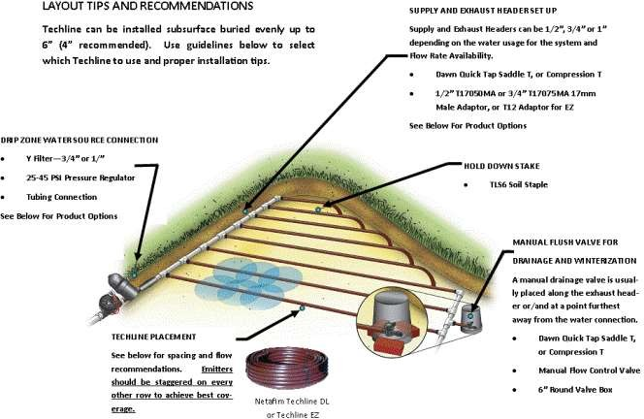

**TOOLS/PLATFORM**

Tools and Platforms Used in the Project:

1. Python: A high-level programming language used for developing the software components of the automated irrigation valve system.

2. TensorFlow: An open-source machine learning framework developed by Google, used for building and training AI models for analyzing and predicting irrigation needs based on weather and soil data.

3. Raspberry Pi: A small, low-cost computer used as the central processing unit (CPU) for the automated irrigation valve system, responsible for controlling the irrigation valves based on the AI predictions.

4. Arduino: An open-source electronics platform used for building the hardware components of the automated irrigation valve system, including the sensors for collecting weather and soil data.

5. Weather API: An application programming interface (API) used for accessing real-time weather data, which is used as input for the AI model to predict irrigation needs.

6. Soil Moisture Sensors: Sensors used for measuring the moisture levels in the soil, which is used as input for the AI model to predict irrigation needs.

7. Cloud Platform: A cloud-based platform used for storing and processing the large amounts of data collected by the automated irrigation valve system, as well as for hosting the AI model.

8. MQTT Protocol: A lightweight messaging protocol used for communication between the Raspberry Pi and the Arduino, as well as between the Raspberry Pi and the cloud platform.

9. Docker: A platform used for containerization, which allows for easy deployment and scaling of the automated irrigation valve system.

10. Git: A version control system used for managing the source code of the automated irrigation valve system, allowing for collaboration and tracking of changes.

11. Jupyter Notebook: An open-source web application used for creating and sharing documents that contain live code, equations, visualizations, and narrative text, which is used for developing and testing the AI model.

**HARDWARE & SOFTWARE REQUIREMENTS**

**HARDWRE:-**

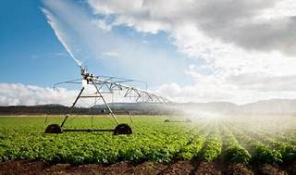

some of the hardware that are required for smart irrigation system using AI are:

* [**NodeMCU ESP8266**: This is a microcontroller that can connect to the internet and communicate with the sensors and actuators](https://circuitdigest.com/microcontroller-projects/iot-based-smart-irrigation-system-using-esp8266-and-soil-moisture-sensor)[1](https://circuitdigest.com/microcontroller-projects/iot-based-smart-irrigation-system-using-esp8266-and-soil-moisture-sensor).
* [**Soil Moisture Sensor Module**: This is a sensor that can measure the water content in the soil and send the data to the microcontroller](https://circuitdigest.com/microcontroller-projects/iot-based-smart-irrigation-system-using-esp8266-and-soil-moisture-sensor)[1](https://circuitdigest.com/microcontroller-projects/iot-based-smart-irrigation-system-using-esp8266-and-soil-moisture-sensor).
* [**Water Pump Module**: This is an actuator that can pump water to the plants according to the irrigation schedule](https://circuitdigest.com/microcontroller-projects/iot-based-smart-irrigation-system-using-esp8266-and-soil-moisture-sensor)[1](https://circuitdigest.com/microcontroller-projects/iot-based-smart-irrigation-system-using-esp8266-and-soil-moisture-sensor).
* [**Relay Module**: This is a device that can switch on and off the water pump based on the signal from the microcontroller](https://circuitdigest.com/microcontroller-projects/iot-based-smart-irrigation-system-using-esp8266-and-soil-moisture-sensor)[1](https://circuitdigest.com/microcontroller-projects/iot-based-smart-irrigation-system-using-esp8266-and-soil-moisture-sensor).
* [**DHT11**: This is a sensor that can measure the temperature and humidity of the ambient and send the data to the microcontroller](https://circuitdigest.com/microcontroller-projects/iot-based-smart-irrigation-system-using-esp8266-and-soil-moisture-sensor)[1](https://circuitdigest.com/microcontroller-projects/iot-based-smart-irrigation-system-using-esp8266-and-soil-moisture-sensor).
* [**Solenoid Valves**: These are actuators that can control the flow of water to different zones of the field based on the signal from the microcontroller](https://circuitdigest.com/microcontroller-projects/iot-based-smart-irrigation-system-using-esp8266-and-soil-moisture-sensor)[2](https://link.springer.com/chapter/10.1007/978-981-16-9154-6_57).
* [**Solar Panels and Lithium Batteries**: These are devices that can provide renewable energy and power supply to the smart irrigation system](https://circuitdigest.com/microcontroller-projects/iot-based-smart-irrigation-system-using-esp8266-and-soil-moisture-sensor)[2](https://link.springer.com/chapter/10.1007/978-981-16-9154-6_57).
* [**Camera**: This is a device that can capture images of the plant leaves and send them to the image processing software](https://circuitdigest.com/microcontroller-projects/iot-based-smart-irrigation-system-using-esp8266-and-soil-moisture-sensor)[3](https://link.springer.com/article/10.1007/s00521-023-08987-y).

**SOFTWARE:-**

The language which we shall be use to make this project is “Python ” language.

We can use the Microsoft office.

We have used window 10 operating system.

**DATA FLOW DIAGRAM**

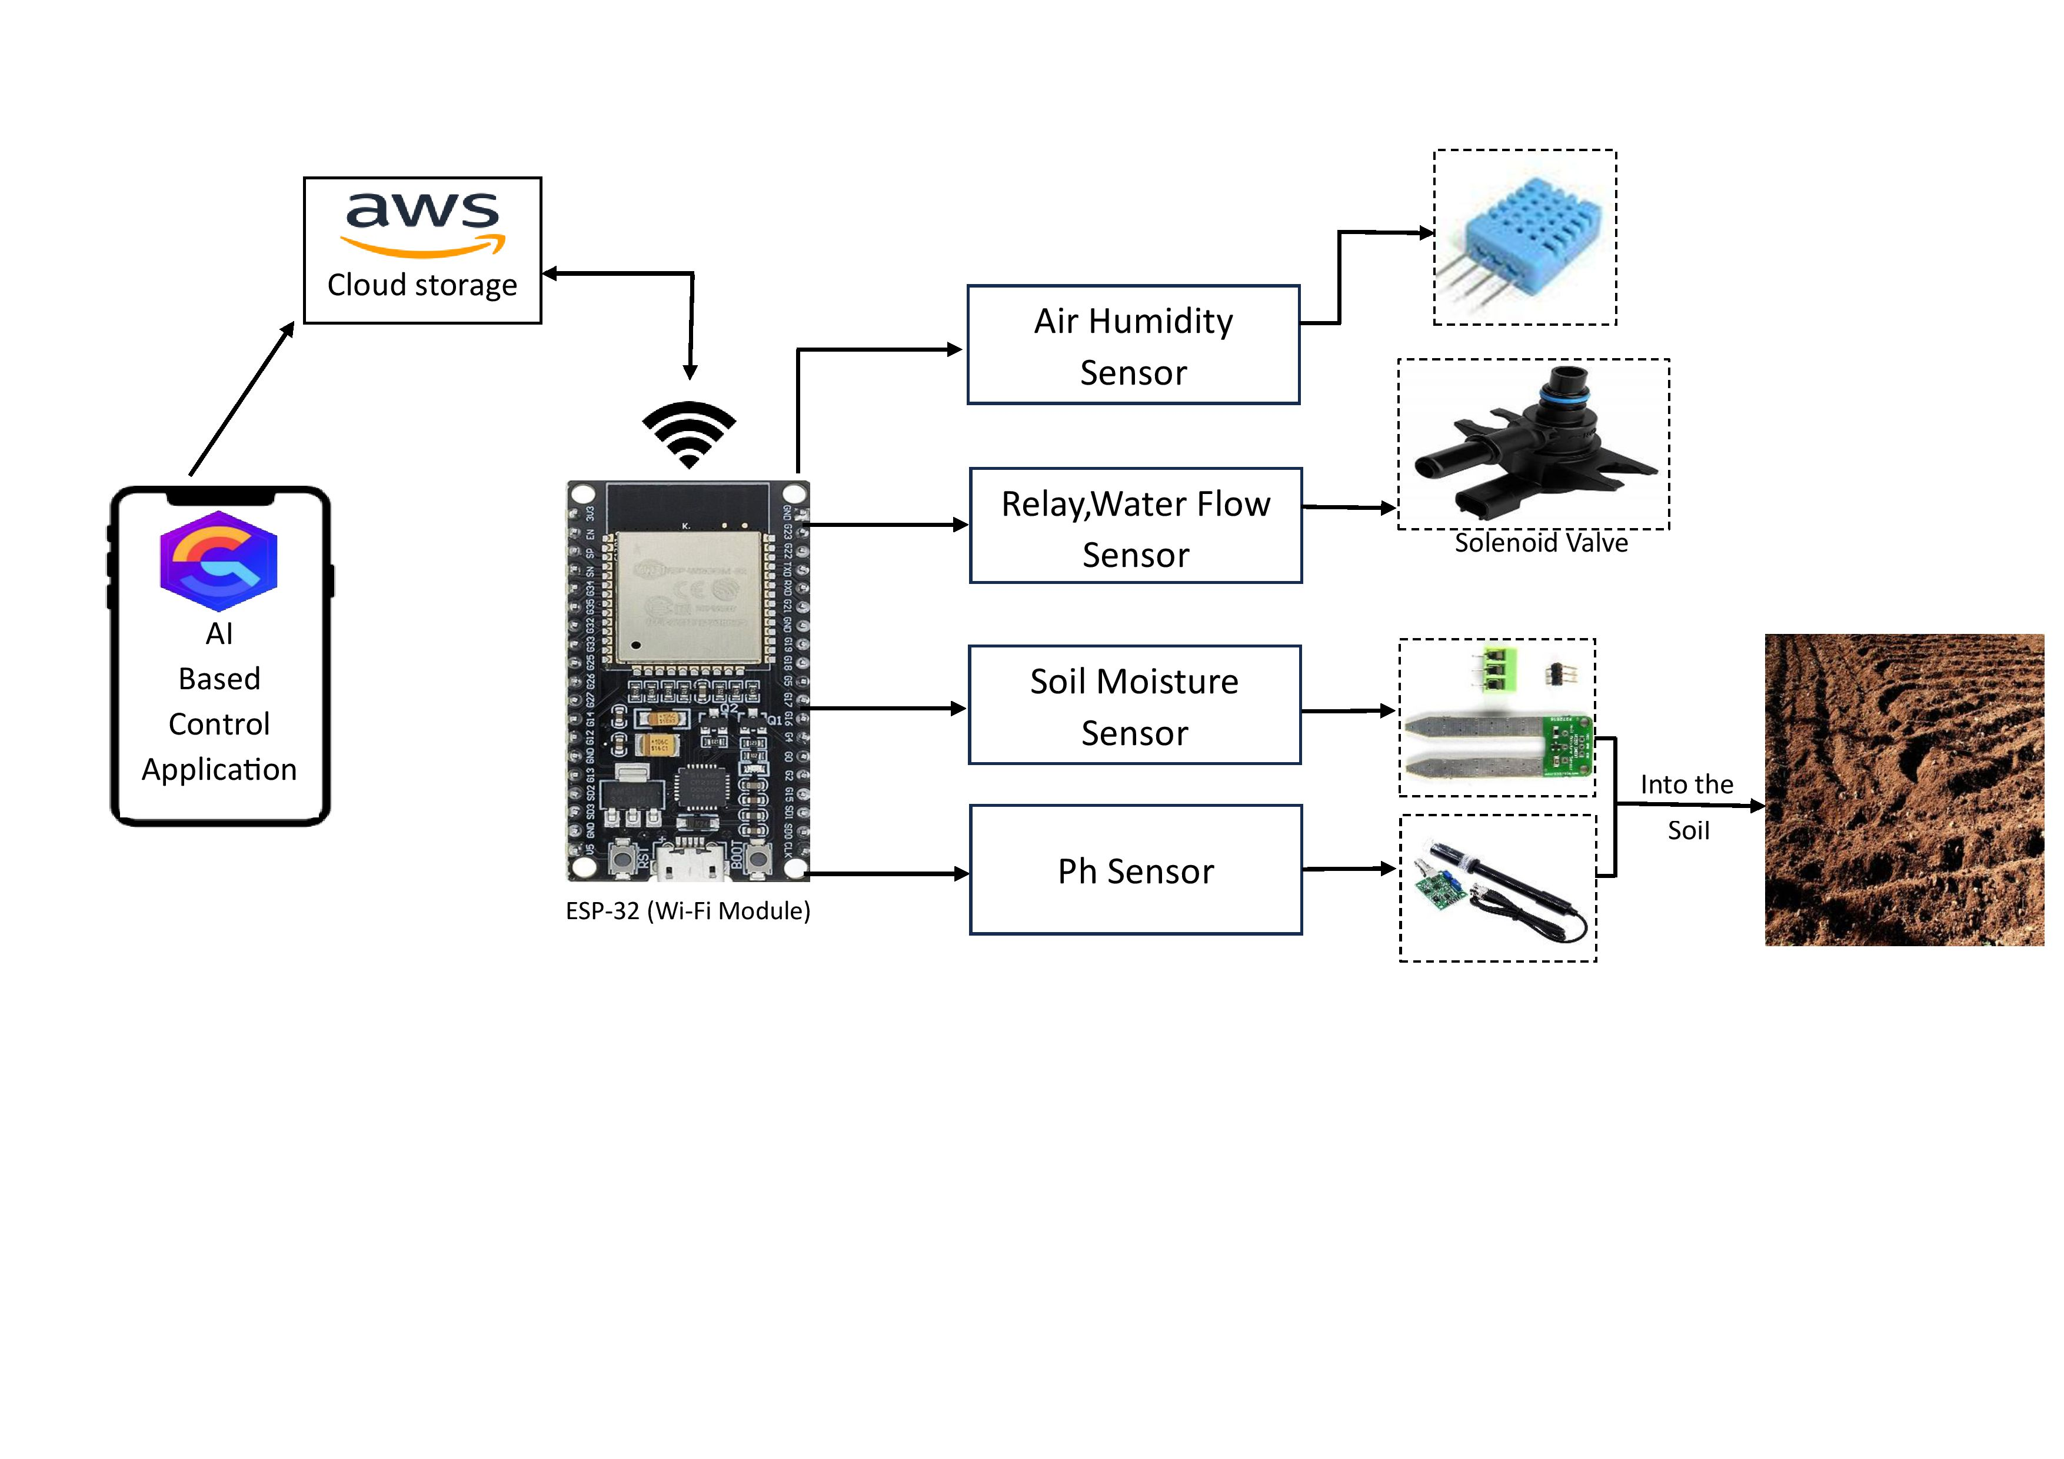

* **Valve Status(On/Off)**
  + **User Interface**
  + **Internet of Things**
  + **Data Collection**
  + **Neural Network(DL)**

**MODULES**

**Administrator:-**

1. Sensors

These are the set of sensors that are used to determine when the automated irrigation system needs to be turned on. A variety of factors can be taken into consideration when determining that the automated irrigation system needs to be switched on, depending on the application of the system.

For water irrigation, the amount of moisture in the soil will be the primary measurement used in determining the threshold for switching on the system, as well as the humidity. For frost protection, the temperature of the soil surface may be the criteria needed in determining when the system needs to be switched on. The automated irrigation system can also be used to ensure livestock have a continuous supply of fresh drinking water. For this particular case, a water level sensor will be needed to determine when the level of water in the drinking trough has fallen below a minimum level. Some of the sensors used in the automated irrigation system are shown in Figure 4.

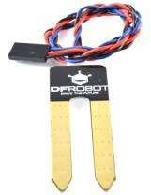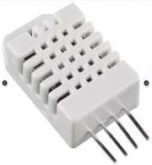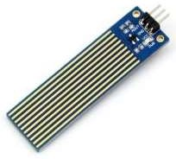

* 1. (b) (c)

**Figure 4.** Sensors used in Automated Irrigation System [8] (a) Moisture Level Sensor (b) Humidity and Temperature Sensor (c) Liquid Level Sensor

**User:-**

According to the web search results, the user preference for smart irrigation system app depends on various factors, such as:

* [The **functionality** and **features** of the app, such as remote monitoring and control, automation, scheduling, data analytics, notifications, etc.](https://circuitdigest.com/microcontroller-projects/smart-irrigation-system-using-esp32-and-blynk-app)[1](https://circuitdigest.com/microcontroller-projects/smart-irrigation-system-using-esp32-and-blynk-app)[2](https://symfa.com/cases/automated-irrigation-react-native-app)[3](https://irrigationtoday.org/features/smart-irrigation-apps-at-your-fingertips/)[4](https://www.g2.com/categories/smart-irrigation-systems)
* [The **user interface** and **user experience** of the app, such as intuitive design, easy navigation, clear instructions, feedback, etc.](https://circuitdigest.com/microcontroller-projects/smart-irrigation-system-using-esp32-and-blynk-app)[1](https://circuitdigest.com/microcontroller-projects/smart-irrigation-system-using-esp32-and-blynk-app)[2](https://symfa.com/cases/automated-irrigation-react-native-app)[3](https://irrigationtoday.org/features/smart-irrigation-apps-at-your-fingertips/)[4](https://www.g2.com/categories/smart-irrigation-systems)
* [The **compatibility** and **connectivity** of the app, such as support for different devices, platforms, sensors, and networks.](https://circuitdigest.com/microcontroller-projects/smart-irrigation-system-using-esp32-and-blynk-app)[1](https://circuitdigest.com/microcontroller-projects/smart-irrigation-system-using-esp32-and-blynk-app)[2](https://symfa.com/cases/automated-irrigation-react-native-app)[3](https://irrigationtoday.org/features/smart-irrigation-apps-at-your-fingertips/)[4](https://www.g2.com/categories/smart-irrigation-systems)
* [The **reliability** and **security** of the app, such as data accuracy, privacy, backup, etc.](https://circuitdigest.com/microcontroller-projects/smart-irrigation-system-using-esp32-and-blynk-app)[1](https://circuitdigest.com/microcontroller-projects/smart-irrigation-system-using-esp32-and-blynk-app)[2](https://symfa.com/cases/automated-irrigation-react-native-app)[3](https://irrigationtoday.org/features/smart-irrigation-apps-at-your-fingertips/)[4](https://www.g2.com/categories/smart-irrigation-systems)
* [The **cost** and **benefit** of the app, such as affordability, return on investment, water saving, crop yield, etc.1](https://circuitdigest.com/microcontroller-projects/smart-irrigation-system-using-esp32-and-blynk-app)[5](https://www.mdpi.com/2073-4441/11/10/1996)[3](https://irrigationtoday.org/features/smart-irrigation-apps-at-your-fingertips/)[4](https://www.g2.com/categories/smart-irrigation-systems)

**FUTURE SCOPE**

According to the web search results, the future scope of smart irrigation system using AI is very promising and has many benefits for agriculture and environment. Some of the possible future scopes are:

* [The smart irrigation system can be more intelligent and predictive by using machine learning algorithms and big data analytics to optimize water use and crop yield](https://dipslab.com/smart-irrigation-system/)[1](https://dipslab.com/smart-irrigation-system/)[2](https://link.springer.com/article/10.1007/s00521-023-08987-y).
* [The smart irrigation system can be integrated with other IoT devices and cloud platforms to enable remote monitoring and control of irrigation parameters and crop conditions](https://dipslab.com/smart-irrigation-system/)[3](https://www.ijariit.com/manuscripts/v5i2/V5I2-1894.pdf)[4](https://ijrti.org/papers/IJRTI2212081.pdf).
* [The smart irrigation system can be expanded to cover different types of crops and irrigation methods, such as drip irrigation, sprinkler irrigation, and flood irrigation](https://dipslab.com/smart-irrigation-system/)[5](https://ijcrt.org/papers/IJCRT2102329.pdf).
* [The smart irrigation system can be enhanced with more sensors and actuators to measure and adjust soil nutrients, pH, salinity, and pest infestation](https://dipslab.com/smart-irrigation-system/)[1](https://dipslab.com/smart-irrigation-system/)[4](https://ijrti.org/papers/IJRTI2212081.pdf).
* [The smart irrigation system can be combined with renewable energy sources, such as solar panels and wind turbines, to reduce the carbon footprint and operational cost of irrigation](https://dipslab.com/smart-irrigation-system/)[1](https://dipslab.com/smart-irrigation-system/)[4](https://ijrti.org/papers/IJRTI2212081.pdf).

**REFRENCES**

1. [www.cdc.gov](http://www.cdc.gov/)
2. Canadian Environmental Quality Guidelines. Protocols for Deriving Water Quality Guidelines for the Protection of Agricultural Water Uses (Irrigation and Livestock Water), Canadian Council of Ministers of the Environment, 1999.
3. [www.statcan.gc.ca](http://www.statcan.gc.ca/)
4. [www.southerndrip.com](http://www.southerndrip.com/)
5. [www.cadmanpower.com](http://www.cadmanpower.com/)
6. [www.agr.gc.ca](http://www.agr.gc.ca/)
7. [www.irrigationdirect.ca](http://www.irrigationdirect.ca/)
8. [www.robotshop.ca](http://www.robotshop.ca/)
9. [www.homedepot.ca](http://www.homedepot.ca/)
10. [www.kijiji.ca](http://www.kijiji.ca/)
11. [www.irrigationdepot.ca](http://www.irrigationdepot.ca/)